Name:____________________________________ Section:_______________ Date:_______________________

Worksheet 2: Parasite Life Cycles

**Part 1: Hands on Portion looking at *Schistosoma* spp.**

The three most common *Schistosoma spp* that cause Schistosomiasis in humans are…

***S. japonicum*** , ***S. mansoni***, and ***S. haematobium*.** The general diagram of their lifecycle is described below.

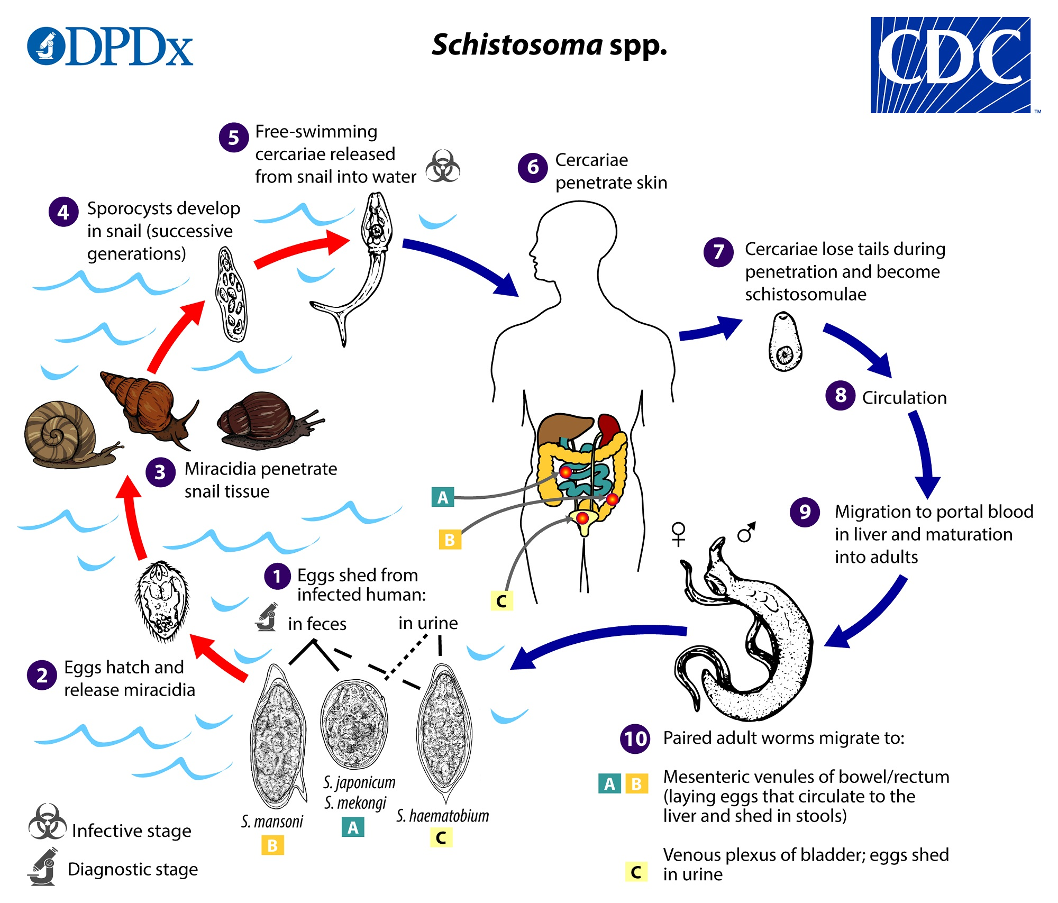

*Schistosoma* eggs are eliminated with feces or urine, depending on species  . Under appropriate conditions the eggs hatch and release miracidia  , which swim and penetrate specific snail intermediate hosts  . The stages in the snail include two generations of sporocysts  and the production of cercariae  . Upon release from the snail, the infective cercariae swim, penetrate the skin of the human host  , and shed their forked tails, becoming schistosomulae  . The schistosomulae migrate via venous circulation to lungs, then to the heart, and then develop in the liver, exiting the liver via the portal vein system when mature,   . Male and female adult worms copulate and reside in the mesenteric venules, the location of which varies by species (with some exceptions)  . For instance, *S. japonicum* is more frequently found in the superior mesenteric veins draining the small intestine  , and *S. mansoni* occurs more often in the inferior mesenteric veins draining the large intestine  . However, both species can occupy either location and are capable of moving between sites. *S. intercalatum* and *S. guineensis* also inhabit the inferior mesenteric plexus but lower in the bowel than *S. mansoni*. *S. haematobium* most often inhabitsin the vesicular and pelvic venous plexus of the bladder  , but it can also be found in the rectal venules. The females (size ranges from 7–28 mm, depending on species) deposit eggs in the small venules of the portal and perivesical systems. The eggs are moved progressively toward the lumen of the intestine (*S. mansoni*,*S. japonicum, S. mekongi, S. intercalatum/guineensis*) and of the bladder and ureters (*S. haematobium*), and are eliminated with feces or urine, respectively  . **In today’s lab, we’re going to be identifying samples of *Schistosoma* spp. to their developmental stage.**

**Egg Stage:**

Eggs are the infective stage shed by mature worms of all three species, either through feces or urine depending on the species. This is also the easiest stage to tell these species apart, depending on the size of the egg and spine placement on the integument. Below, sketch the eggs of each of the three species we’re looking at today, specifying the magnification you’re drawing at.

| **S. japonicum ( X Mag)** | **S. mansoni ( X Mag)** | **S. haematobium( X Mag)** |
| --- | --- | --- |

Eggs are relatively easy to assign to species when alone, but can be more difficult to identify in host tissue. In host tissues, eggs cause the host cells to create immune aggregates around the called “egg granulomas,” which may actually facilitate the extrusion of the egg through the gut lumen (Takaki, 2021). In host tissues you can use the same spine pattern to differentiate between S species, but be careful and try to check multiple-the spines can sometimes be hard to see! Below, sketch what you see in tissue samples containing each species.

| **S. japonicum in tissue ( X Mag)** | **S. mansoni in tissue( X Mag)** | **S. haematobium in tissue( X Mag)** |
| --- | --- | --- |

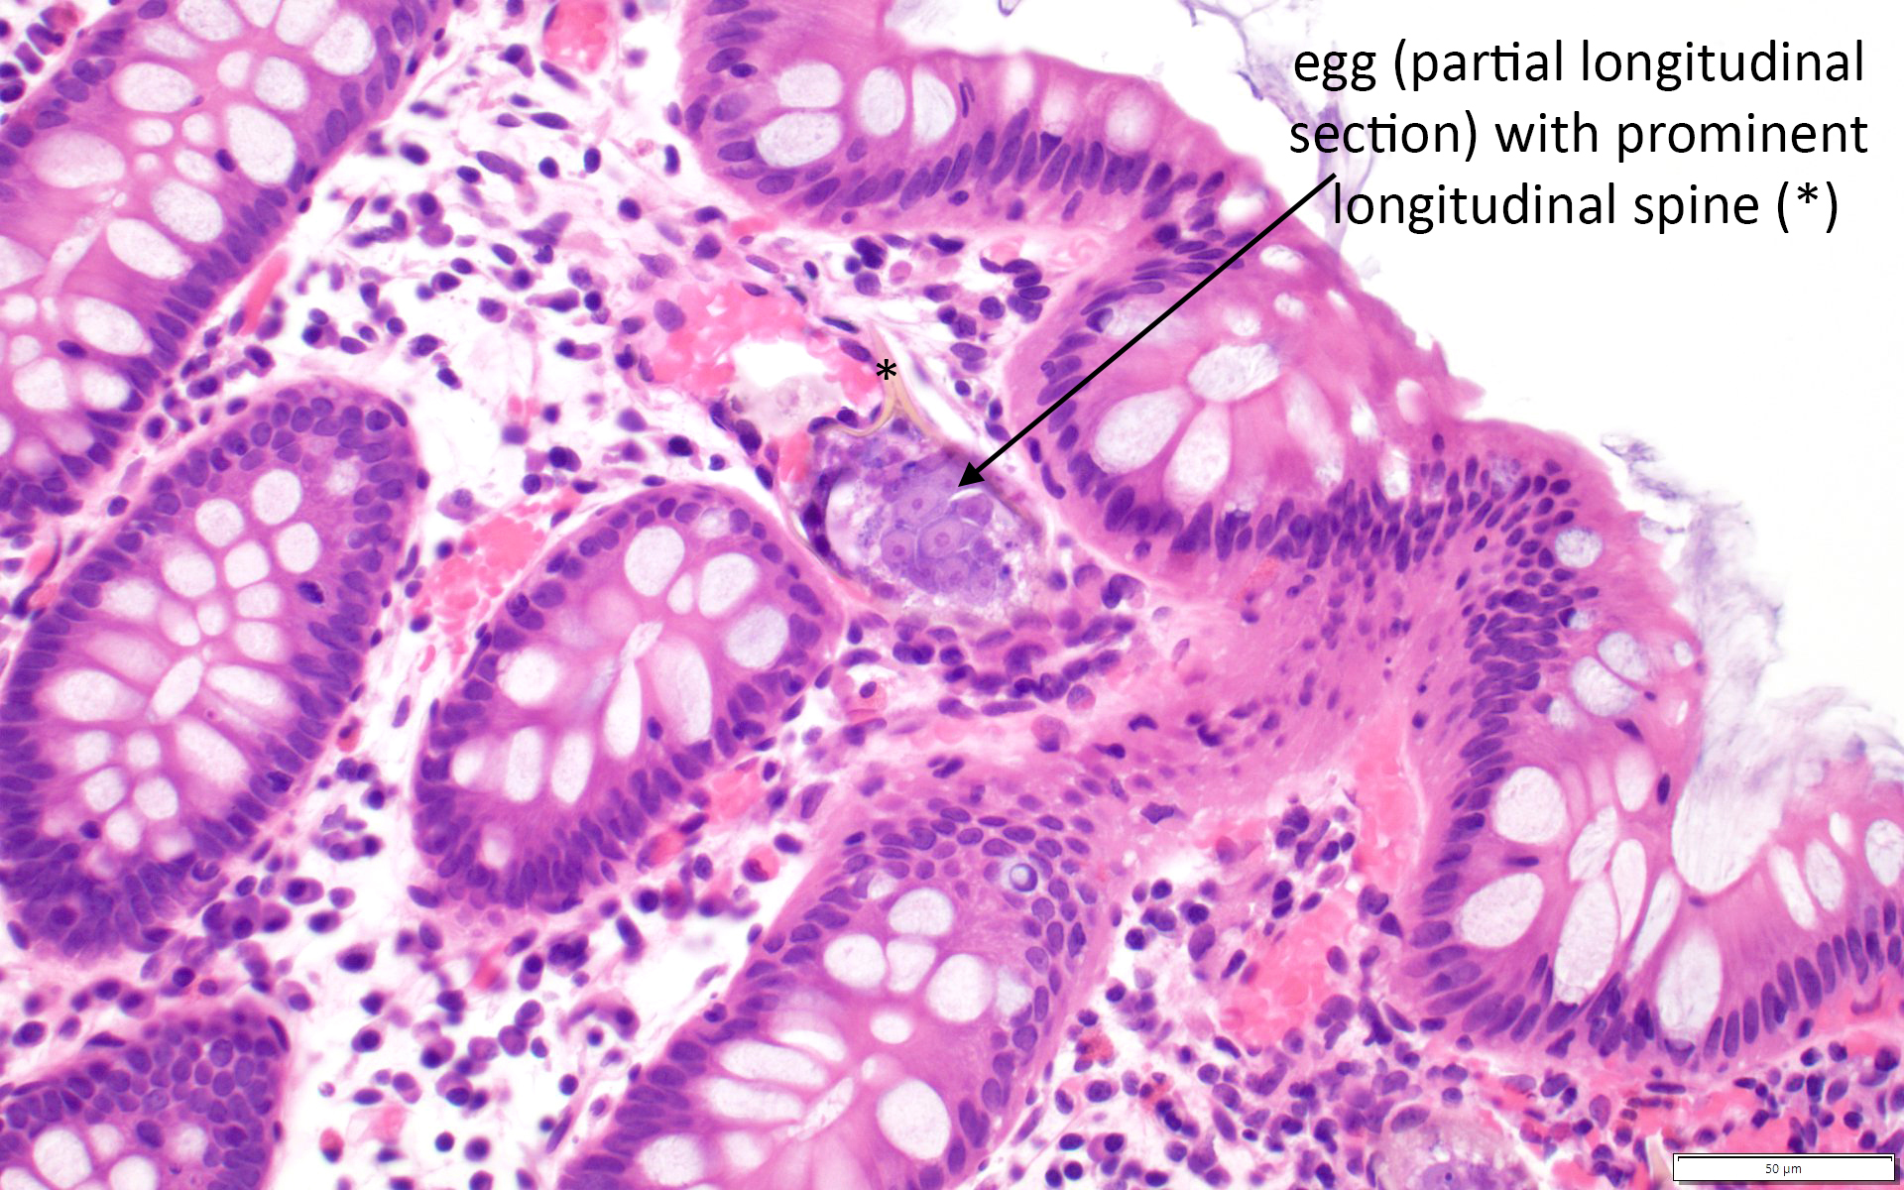 **Above:** A S. mansoni egg in host tissue. Note the characteristic lateral spine. 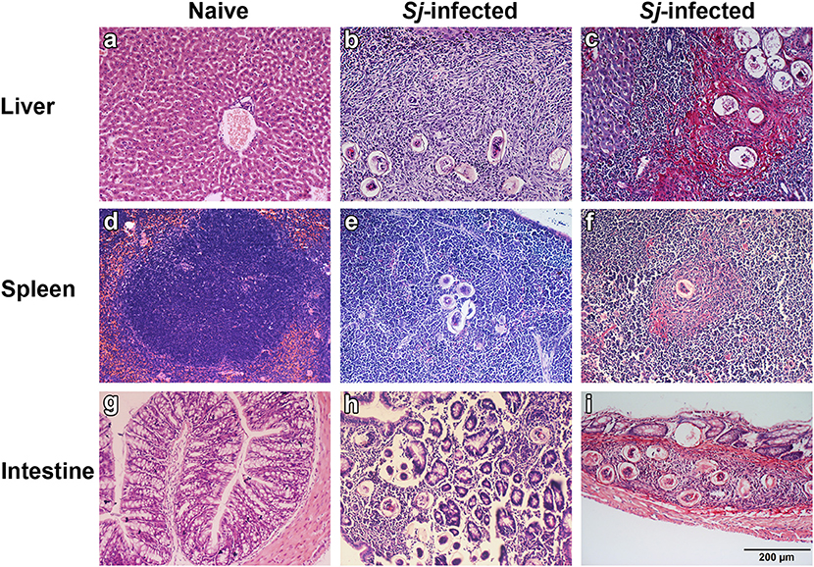

**Left:** Three mouse tissues infected with S. japonicum.

**Miracidium Stage:** Eggs hatch into miracidia, which are flagellated to move through the water and find their snail host. We don’t have any miracidia samples for you to ID, but here are some microscope images of miracidia so you can see what they look like at least.

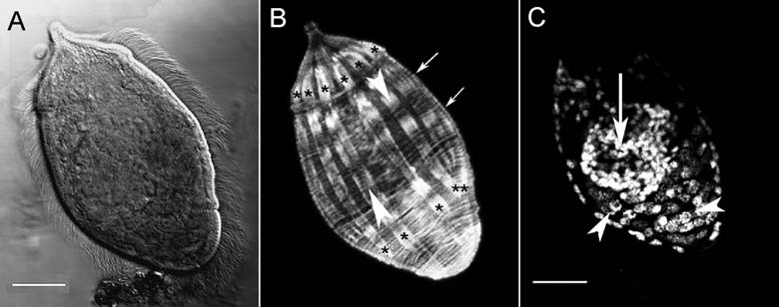

**Sporocyst Stage:** This stage occurs inside the intermediate host, a freshwater snail. Miracidium that successfully infect a snail undergo differentiation to become a mother sporocyst, which produce daughter sporocysts. Daughter sporocysts migrate to digestive or reproductive glands, where they begin producing cercariae to io infect new hosts.

**=**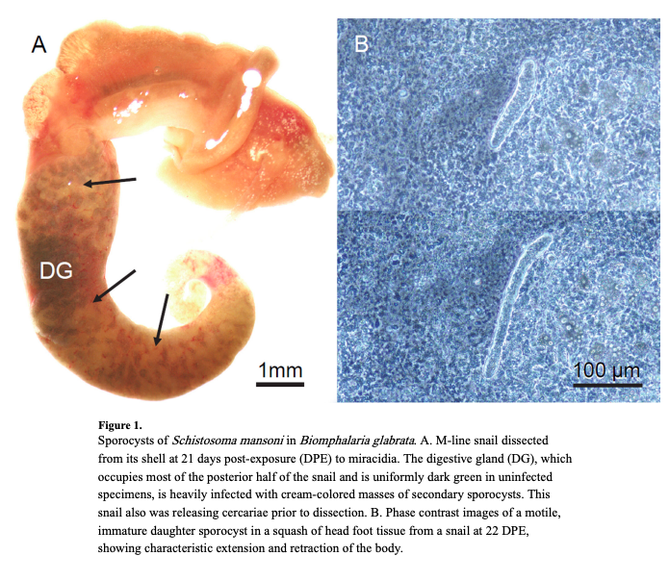

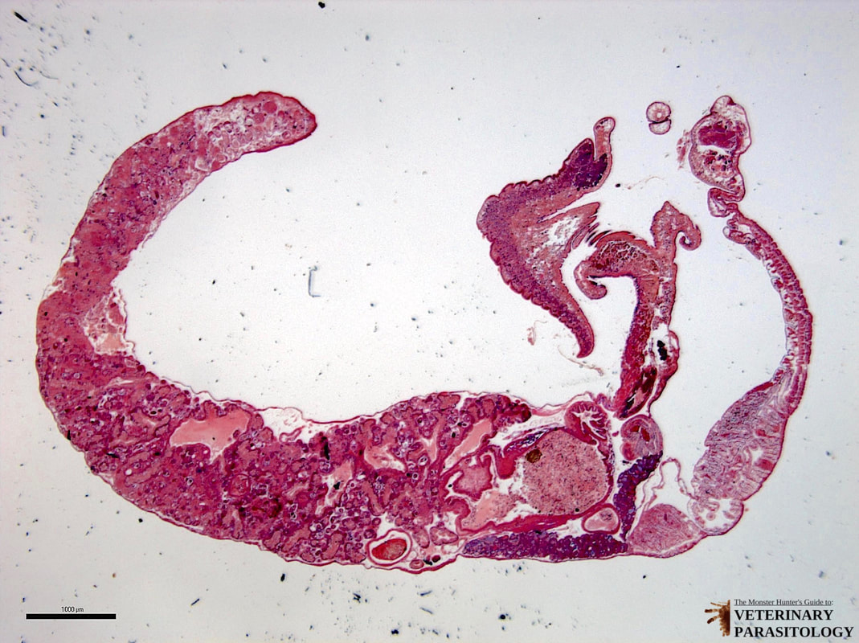

**Draw a sketch of the sporocyst sample here:**

| **Sporocyst of S. mansoni ( X Mag)** |
| --- |

**Cercarial Stage:** One of the most recognizable stage of trematodes, the cercaria are produced by the sporocysts into the environment, where they seek to infect a human host.

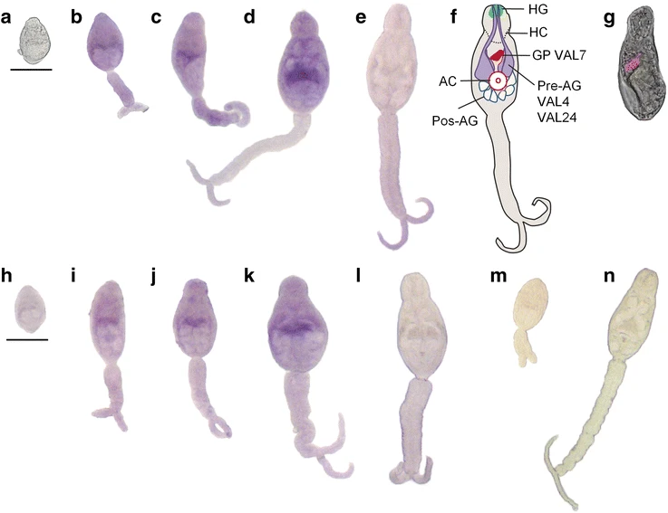

Below, make a sketch of 2 or more *S. mansoni* cercariae and specify under what magnification you’re viewing them.

| **Cercariae of S. mansoni ( X Mag)** |
| --- |

**Part 2: Guinea Worm Case Study**

**Section A.**

Read the associated introduction to Guinea Worm biology and human health (excerpt from Greenaway, 2004). Once done, your task is to work with your group members to develop 3 intervention strategies to reduce intervention strategies in rural Africa. Once you’ve identified three potential strategies, choose one (different from other groups) and create a “micro-presentation” on the shared class google slides pitching it as an intervention strategy. The goal is to convince your classmates that your intervention is 1) effective at controlling Guinea Worm, and 2) is achievable

**Intervention Strategy 1:**

Targeted portion of the life cycle:

Pros of this strategy compared to others:

Potential Barriers to implementation:

**Intervention Strategy 2:**

Targeted portion of the life cycle:

Pros of this strategy compared to others:

Potential Barriers to implementation:

**Intervention Strategy 3:**

Targeted portion of the life cycle:

Pros of this strategy compared to others:

Potential Barriers to implementation:

**Section B.**

Potential for alternative hosts: Does the 2014 host jump we talked about in class alter any of the intervention strategies your group chose above?

What do you think this host jump means for the possibility of guinea worm eradication?

**Part 3: Reflection on Poulin Chapter**

Read the excerpt from Poulins’ 2007 edition of the Evolutionary Ecology of Parasites posted on blackboard, and respond to the following questions:

1. Why does Poulin stress the importance of groups like pearlfish or Oenonidae polychaetes for understanding parasite life cycles?
2. What are some of the conditions that may lead a parasite to evolve to incorporate an additional host in its life cycles? Are there any types of environments where you may expect to this more often?
3. What are some conditions that may lead a parasite to abbreviate its life cycles? Are there any types of environments where you may expect to this more often?
4. What’s the biggest one or two takeaways you have from the Poulin chapter that changed the way you might think about how parasite life cycles evolve?
5. Is there any part of the chapter that you weren’t sure about or didn’t agree with?

**Sources (non-comprehensive)**

Greenaway, C. (2004). Dracunculiasis (guinea worm disease). *Canadian Medical Journal*, *170*(4), 495-500.

Takaki, K. K., Rinaldi, G., Berriman, M., Pagán, A. J., & Ramakrishnan, L. (2021). Schistosoma mansoni eggs modulate the timing of granuloma formation to promote transmission. *Cell Host & Microbe*, *29*(1), 58-67.

Nelson, M. K., Cruz, B. C., Buena, K. L., Nguyen, H., & Sullivan, J. T. (2016). Effects of abnormal temperature and starvation on the internal defense system of the schistosome-transmitting snail Biomphalaria glabrata. *Journal of invertebrate pathology*, *138*, 18-23. Doi: I: 10.1016/j.jip.2016.05.009

Doughty, B. L. (1996). Schistosomes and other trematodes. *Medical microbiology. 4th ed. Galveston: University of Texas Medical Branch at Galveston*.